LAWMATE

ABSTRACT
This project serves as a Flask-based web application designed to bridge the gap between Indian society and the legal system by providing AI-powered legal insights. The application leverages Google's Gemini generative AI to interpret complex legal concepts and present them in accessible, human-friendly language across multiple Indian regional dialects.
Key Components
- Dual Interface System: The platform is divided into two primary tools accessible via a central landing page:
  - Legal Rights Guide: A structured tool where users input specific laws (e.g., IPC sections). The system breaks the response into three distinct categories: "Basic Explanation," "Application" (with examples), and "Legal Implications".
  - Unjail-Lawmate (Agent): A conversational chatbot interface designed for immediate legal assistance and personalized advice, capable of maintaining context and responding in specific regional languages.
- Localization & Accessibility: To ensure wide reach, the application supports input and output in English, Hindi, Kannada, Marathi, Tamil, and Telugu.
- AI Integration: The backend utilizes gemini-2.5-flash to act as a legal expert. The system is prompted to provide accurate, concise (30-40 words) advice while maintaining a professional tone.
Technical Architecture
- Backend: The project utilizes Python with the Flask framework. It appears to operate using two distinct service endpoints: the main application logic and a dedicated agent service running on port 50001.
- Frontend: The user interface is built using HTML/CSS, featuring responsive design, animations (e.g., typewriter effects on the landing page), and dynamic content loading via JavaScript.
- API Management: The application requires a Google API key (GEMINI_API_KEY) for operation and manages user sessions to store query context and language preferences.

INTRODUCTION
Lawmate.ai is a web-based platform designed to bridge the gap between Indian society and the legal system. Its primary mission is to democratize legal knowledge by making complex laws accessible, understandable, and actionable for the general public through the use of Artificial Intelligence.
The project leverages Google's Gemini AI (specifically the gemini-2.5-flash model) to act as a virtual legal expert, offering instant clarifications and advice in simple terms.

Core Components
The platform is divided into two distinct functional areas, accessible from the home page:
- Legal Rights Guide:
  - This tool allows users to input specific legal queries (e.g., "IPC 302") and receive structured breakdowns.
  - The AI provides three levels of detail for every query: a Basic Explanation in simple terms, real-world Application examples, and the Legal Implications of the law.
- Unjail-Lawmate (AI Agent):
  - This is a conversational chatbot interface capable of acting as a legal expert.
  - It is designed for immediate interaction, providing concise advice (30-40 words) and personalized consultation while maintaining a professional yet human-friendly tone.

Key Features
- Multilingual Support: Recognizing the diversity of its user base, the platform supports six languages: English, Hindi, Kannada, Marathi, Tamil, and Telugu.
- Simplified Legal Jargon: The system automatically formats responses to remove complex symbols and structures, ensuring the output is easy to read for non-experts.
- Dual Interface: Users can choose between a structured educational guide or a direct conversational agent depending on their immediate needs.

LITERATURE SURVEY
The development of lawmate is grounded in three primary domains: the accessibility of legal information in India, the application of Generative AI for text simplification, and the necessity of multilingual digital interfaces for regional inclusivity.
1. The Legal Knowledge Gap and Accessibility
The primary motivation for this system is the disconnect between complex legal frameworks and the general public.
- Problem Identification: The project identifies a significant "legal knowledge gap between Indian society and the law".
- Current Challenges: Traditional legal resources are often laden with jargon, making them inaccessible to laypeople. The project addresses this by proposing a "Legal Rights Guide" that breaks down laws into "Basic Explanation," "Application," and "Legal Implications" to ensure clarity.
- Objective: The goal is to provide a trusted solution that bridges this gap, creating a platform where users can easily understand their rights without needing immediate, expensive professional intervention.
2. Generative Artificial Intelligence in Legal Tech
To solve the issue of complexity, the project leverages state-of-the-art Large Language Models (LLMs).
- Model Utilization: The system utilizes Google's Gemini AI, specifically the gemini-2.5-flash model, to act as the core intelligence engine.
- Prompt Engineering: The "literature" of this project involves specific prompt engineering techniques to ensure output quality. The system uses structured prompts to instruct the AI to:
  - Act as a "legal expert specializing in Indian law".
  - Format responses to be "human-friendly" and concise (30-40 words).
  - Simplify output by removing complex formatting symbols (e.g., asterisks) to improve readability for the end-user.
- Contextualization: The AI is specifically programmed to include relevant Indian Penal Code (IPC) sections, ensuring that the simplified advice remains legally grounded.
3. Multilingual Natural Language Processing (NLP)
Given India's linguistic diversity, English-only legal resources are insufficient.
- Regional Language Support: The project integrates a multilingual support layer, acknowledging that effective legal assistance must be available in the user's native tongue. The system architecture supports English, Hindi, Kannada, Marathi, Tamil, and Telugu.
- Implementation: The backend explicitly maps language codes (e.g., 'kn': 'Kannada', 'te': 'Telugu') to ensure the AI generates responses in the correct target language, thereby democratizing access to legal advice across different demographics.
4. Conversational Agents vs. Static Search
The project explores two distinct modes of human-computer interaction (HCI) for legal inquiry.
- Static Information Retrieval: The "Legal Rights Guide" follows a traditional query-response model where users input a specific law (e.g., "IPC 302") and receive structured data.
- Conversational AI: The "Unjail-Lawmate" agent represents a shift towards conversational interfaces. This module allows for free-form dialogue ("Type your legal query..."), where the system maintains a chat history (chat-container) to simulate a consultation with a human expert.
5. Web Architecture and Scalability
- Framework: The application is built upon Flask, a lightweight Python web framework, which manages the routing between the user interface and the AI backend.
- Session Management: The system utilizes server-side session management to store user context (queries and language preferences) across different endpoints, ensuring a seamless user experience during multi-step interactions.

OBJECTIVES
The primary objective of Lawmate.ai is to bridge the legal knowledge gap between Indian society and the law.
To achieve this, the project focuses on the following specific goals:
- Democratize Legal Knowledge: To harness the power of AI to simplify complex legal jargon into clear, actionable insights for the general public.
- Ensure Linguistic Inclusivity: To provide legal assistance and explanations in multiple Indian languages—specifically English, Hindi, Kannada, Marathi, Tamil, and Telugu—ensuring access for diverse demographics.
- Provide Instant Legal Aid: To connect users with AI Agents for immediate assistance and personalized advice through a conversational chatbot interface.
- Offer Structured Legal Education: To help users understand laws thoroughly by providing three distinct layers of information: a basic explanation in simple terms, examples of when the law is applied, and the specific legal implications.
- Deliver Accurate & Concise Counsel: To utilize Google Gemini AI to act as a legal expert specializing in Indian law, delivering accurate responses that are concise (30-40 words) and professionally toned.
- Enhance Readability: To automatically clean and format AI-generated responses (removing unwanted symbols) to make legal advice human-friendly and easy to read.
METHODOLOGY
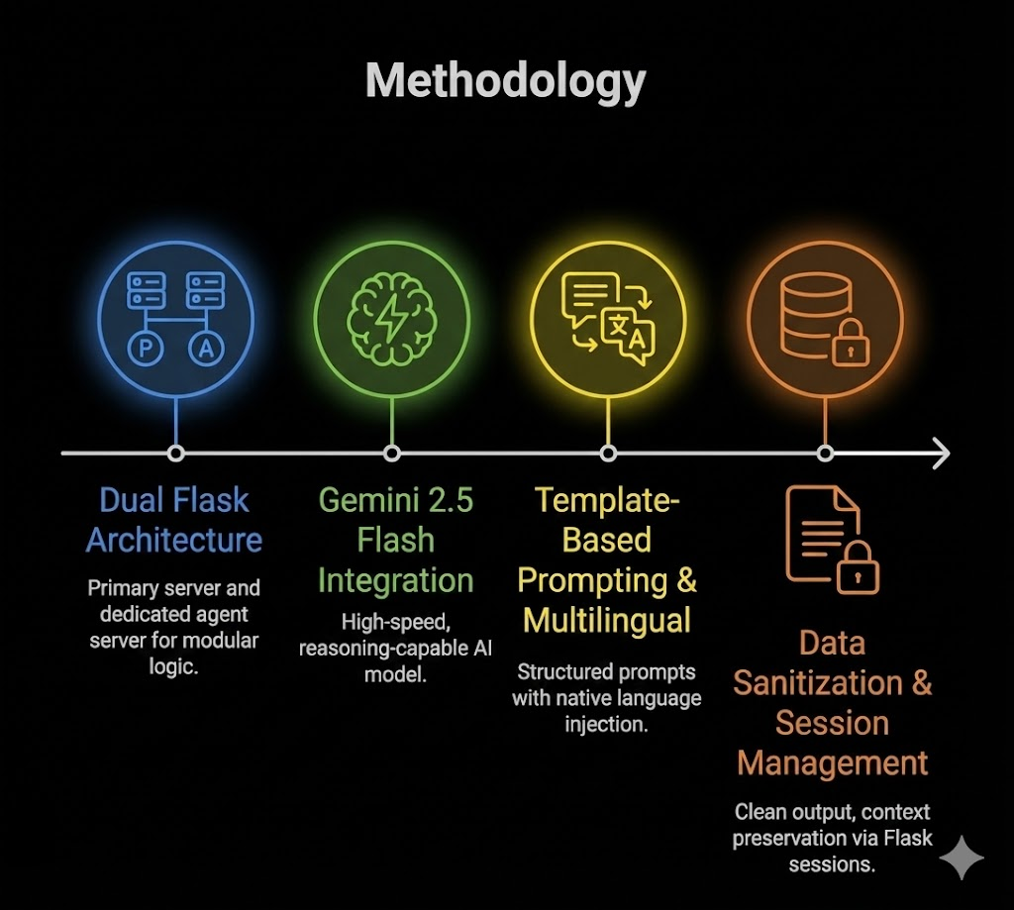
Fig.no 1

Based on the project's source code, here is the Methodology summarized in sentences:
The project is built upon a modular Flask web architecture that utilizes two distinct server instances to separate the main application logic from the conversational AI agent. The core intelligence is powered by Google's Gemini 2.5 Flash model, selected for its ability to rapidly process natural language and simplify complex legal concepts. To ensure accuracy, the system employs a template-based prompt engineering approach, strictly instructing the AI to act as an Indian legal expert and cite relevant IPC sections. Multilingual support is implemented through a backend mapping system that dynamically injects language instructions (e.g., Hindi, Tamil) into the prompts based on user selection. The application utilizes server-side sessions to maintain user context, storing queries and language preferences to facilitate a seamless transition between defining, applying, and analyzing laws. Finally, a dedicated data sanitization layer uses regular expressions to clean the AI's raw output, removing Markdown formatting to present clear, human-friendly text to the user.

SOFTWARE REQUIREMENTS
1. Operating System
- Platform Independent: Windows, macOS, or Linux (capable of running Python).
2. Programming Languages & Frameworks
- Python: The core backend programming language.
- Flask: A web micro-framework used to host both the main application server and the agent server.
3. Libraries & Dependencies
- google-generativeai: The client library required to interact with Google's Gemini API.
- python-dotenv: Used for managing environment variables (specifically for securely loading API keys).
- Standard Python Libraries: The system relies on os, re (Regular Expressions for cleaning text), json, webbrowser, and threading.
4. Frontend Technologies
- HTML5 & CSS3: Used for structuring and styling the user interfaces, including the landing page and chat interfaces.
- JavaScript: Required for client-side logic, handling API requests (fetch), and dynamic DOM manipulation (e.g., the typewriter effect).
5. External APIs & Services
- Google Gemini API: Access to the gemini-2.5-flash model is mandatory. A valid GEMINI_API_KEY is required.
6. Development Tools
- Web Browser: A modern web browser (Chrome, Edge, Firefox, etc.) is required to render the application.
- Code Editor/IDE: (Optional but recommended) VS Code or PyCharm for editing the Python and HTML files.
- Git: Required for cloning the repository.

HARDWARE REQUIREMENTS
• Processor (CPU): A standard modern multi-core processor (e.g., Intel Core i3/i5 or AMD Ryzen 3/5) is sufficient. High-performance GPUs are not required locally as the AI model runs on Google's infrastructure.
• Memory (RAM):
- Minimum: 4 GB (to run the Operating System and Python environment).
- Recommended: 8 GB or higher for smoother performance when running the server and web browser simultaneously.
• Storage:
- At least 1 GB of free disk space is needed to install Python, the virtual environment, and necessary libraries like google-generativeai and flask.
• Internet Connection (Critical):
- A stable, active high-speed internet connection is strictly required. The application cannot function offline because it must send requests to the Google Gemini API to generate responses.
• Input/Output Devices:
- Monitor, Keyboard, and Mouse for interacting with the web interface.

EXPECTED RESULT
The Unmute.ai system is expected to deliver accurate, simplified, and legally grounded information across two primary interfaces. The results will be generated in real-time in the user's preferred Indian regional language.
1. Legal Rights Guide Output
When a user queries a specific law (e.g., "IPC 302" for Murder) and selects a language (e.g., "Hindi"), the system is expected to generate three distinct outputs:
- Basic Explanation: A simplified definition of the law, stripping away complex legal terminology so a layperson can understand the core concept.
  - Example Output: "IPC 302 defines the punishment for murder. It states that whoever commits murder shall be punished with death or imprisonment for life and shall also be liable to fine."
- Application: Concrete scenarios illustrating when the law is applied, helping users relate the abstract law to real-world situations.
  - Example Output: "This is applied when a person intentionally causes the death of another person, or causes bodily injury that is likely to cause death."
- Legal Implications: A clear statement of the consequences, including penalties, fines, or jail time, derived from the Indian Penal Code.
  - Example Output: "The legal implication is severe punishment, which can be life imprisonment or the death penalty, depending on the gravity of the offense."
2. Unjail-Unmute Agent (Chatbot) Output
For natural language queries in the chat interface, the system is expected to produce:
- Role-Specific Advice: The AI will act as a "legal expert," providing advice that is authoritative yet accessible.
- Concise Responses: Answers will be kept short (approximately 30-40 words) to ensure they are easy to digest on mobile devices or for quick reading.
- Contextual Relevance: The response will automatically include relevant IPC sections if applicable to the user's query.
3. Performance & Usability
- Multilingual Accuracy: All outputs will be translated into the target language (English, Hindi, Kannada, Marathi, Tamil, or Telugu) while preserving legal accuracy.
- Clean Formatting: The final text displayed on the screen will be free of raw Markdown symbols (like asterisks or hash signs), ensuring a clean, "human-friendly" reading experience.

REFERENCES
- 1. Documentation & Libraries
- Flask Documentation. (n.d.). Flask: The Python Micro Framework. Retrieved from https://flask.palletsprojects.com/.
- Google AI for Developers. (n.d.). Gemini API Documentation & Python SDK (google-generativeai). Retrieved from https://ai.google.dev/.
- Python Dotenv. (n.d.). Read Key-Value Pairs from a .env file. Retrieved from https://pypi.org/project/python-dotenv/.
- 2. Frontend Resources
- Font Awesome. (Version 6.0.0). Icon Library and Toolkit. Retrieved from https://cdnjs.cloudflare.com/ajax/libs/font-awesome/6.0.0/css/all.min.css.
- Google Fonts. (n.d.). Poppins Font Family. Retrieved from https://fonts.googleapis.com/css2?family=Poppins:wght@300;400;600;700&display=swap.
- 3. Application Software
- Google Gemini 2.5 Flash Model. (2024). Generative Language Model. Used for Natural Language Processing and Legal Query Resolution.

